**Experiment no. 10**

**NAME: KARTIK RATHOD**

**BRANCH: COMPS DIV: 3 ROLL NO: 16**

|  |
| --- |
| Experiment No.10 |
| Implementation of Binary Search Method |
| Date of Performance: |
| Date of Submission: |

**Experiment No. 10: Binary Search Method**

**Aim :** Implementation of Binary Search Method

**Objective:** 1) Understand how to implement Binary Search algorithm.

**Theory:**

The improvement to searching method to reduce the amount of work can be done using binary searching. Binary searching is more efficient than linear searching if an array to be searched is in sorted manner.

Here an key item to be searched is compared with the item at middle of array. If they are equal search is completed. If the middle element is greater than key item searching proceeds with left sub array. Similarly, if middle element is less than key item than searching proceeds with right sub array and so on till the element is found.

For large arrays, this method is superior to sequential searching.

**Algorithm**

Algorithm : FIND(arr, x, first, last)

if (first > last)then

return -1

End if

mid = (first + last) / 2

if (arr[mid] = x)

return mid

End if

if (arr[mid] < x)

return find(arr, x, mid+1, last)

End if

return find(arr, x, first, mid-1)

**Code:**

#include<stdio.h>

int binarySearch(int arr[], int size, int element){

int low, mid, high;

low = 0;

high = size-1;

// Keep searching until low <= high

while(low<=high){

mid = (low + high)/2;

if(arr[mid] == element){

return mid;

}

if(arr[mid]<element){

low = mid+1;

}

else{

high = mid -1;

}

}

return -1;

}

int main() {

int arr[]={1,2,3,4,5,6,7,8,9,10};

int size = sizeof (arr)/sizeof (int) ;

int element=7;

int SearchIndex = binarySearch(arr,size,element);

printf("The element %d was found at Index %d\n",element,SearchIndex);

return 0;

}

**output:**

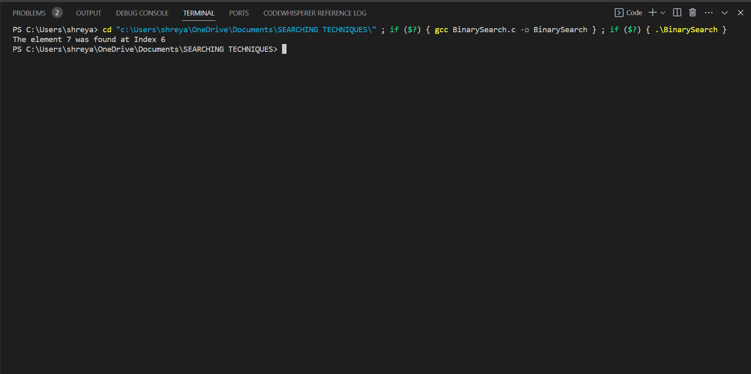



**Conclusion:** Binary search is an efficient and widely used algorithm for finding a specific element within a sorted array or list. It operates by repeatedly dividing the search space in half, which makes it particularly useful for large datasets.

.